The console output: （threshold recall=0.97, precision = 0.9）

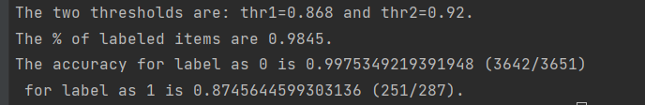

**Inconsistent results:**

1. For fuzzy matching label = 0:  
   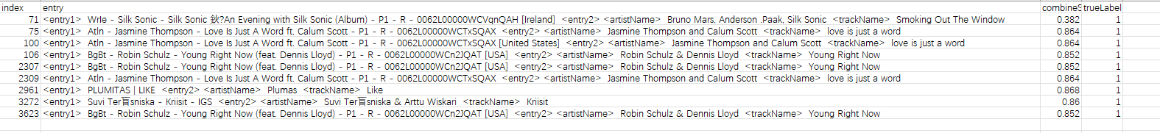
2. #71 is about the album vs track issue reported previously
3. #75, #100, #106, #2307, #2309, #3272, #3623 -- the artistName contains 2 musicians
4. #2961 seems like a typo:  
   
   1. So I manually gave the label as 1.
5. For fuzzy matching label = 1:  
   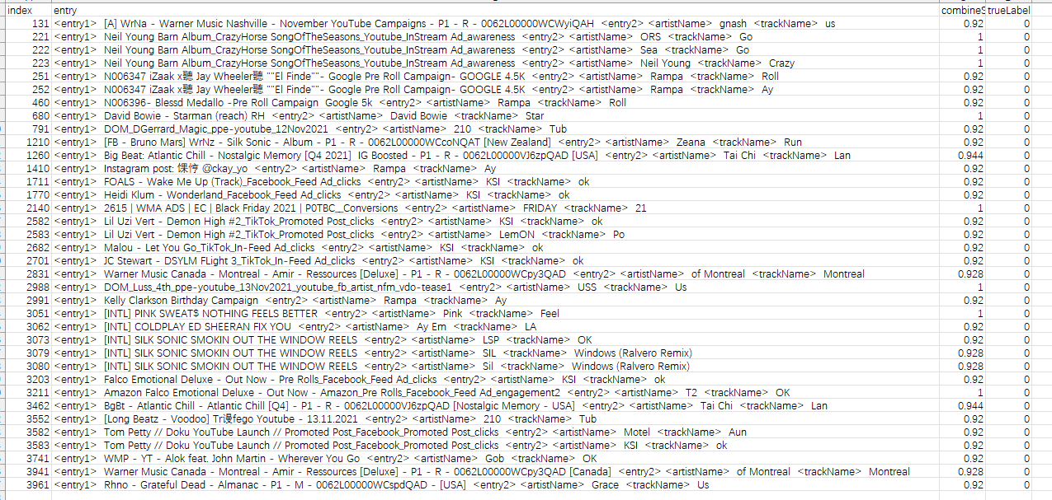
   1. Fuzzy wuzzy limitation:
      1. 131, 221, 222, 223, 680,1260, 2140，2831,2988,3051, 3079, 3080, 3211, 3462, 3941
      2. The artistName, trackName is too simple, and somehow both are overlapped within the campaignName:  
         